**Lab 4 report**

**Mobile client application**

**Step 1:** This is my mobile client android application which displays weather of any city provided by the user.

The following is the home page of my application that gives a textbox to the user for entering the input and output will be displayed on the top of the page.

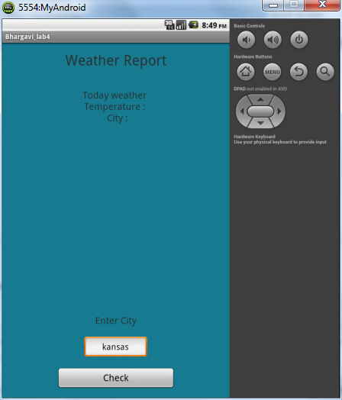

**Step 2:** This is the output page that displays temperture when the user gives the input “Kansas” in the text box.

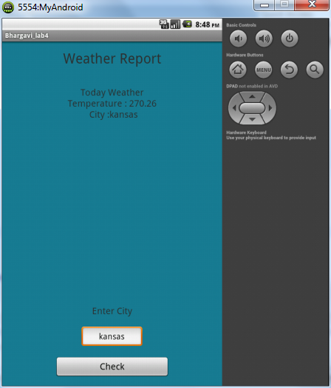

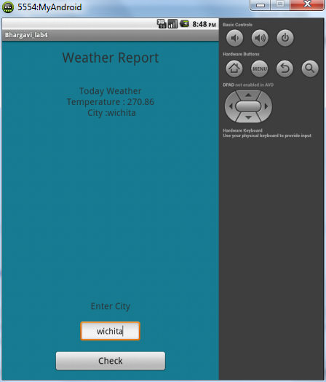**Step 3:** This is the output page that displays temperture when the user gives the input “Wichita” in the text box.

**Step 4:** This is the output page that displays temperture when the user gives the input “Topeka” in the text box.

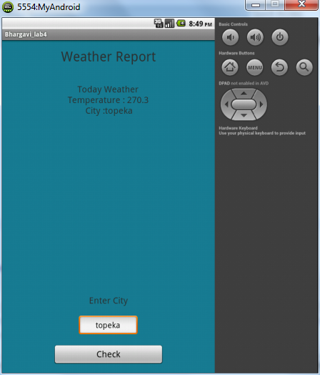

**Web service**

I have created my web service using REST and SOAP service. This is the output page of the web service which I have developed.

**Step 1:** This shows three different options for the user ie. Insert, delete and query table. These are the links which the users will be using to perform any operation using my web service.

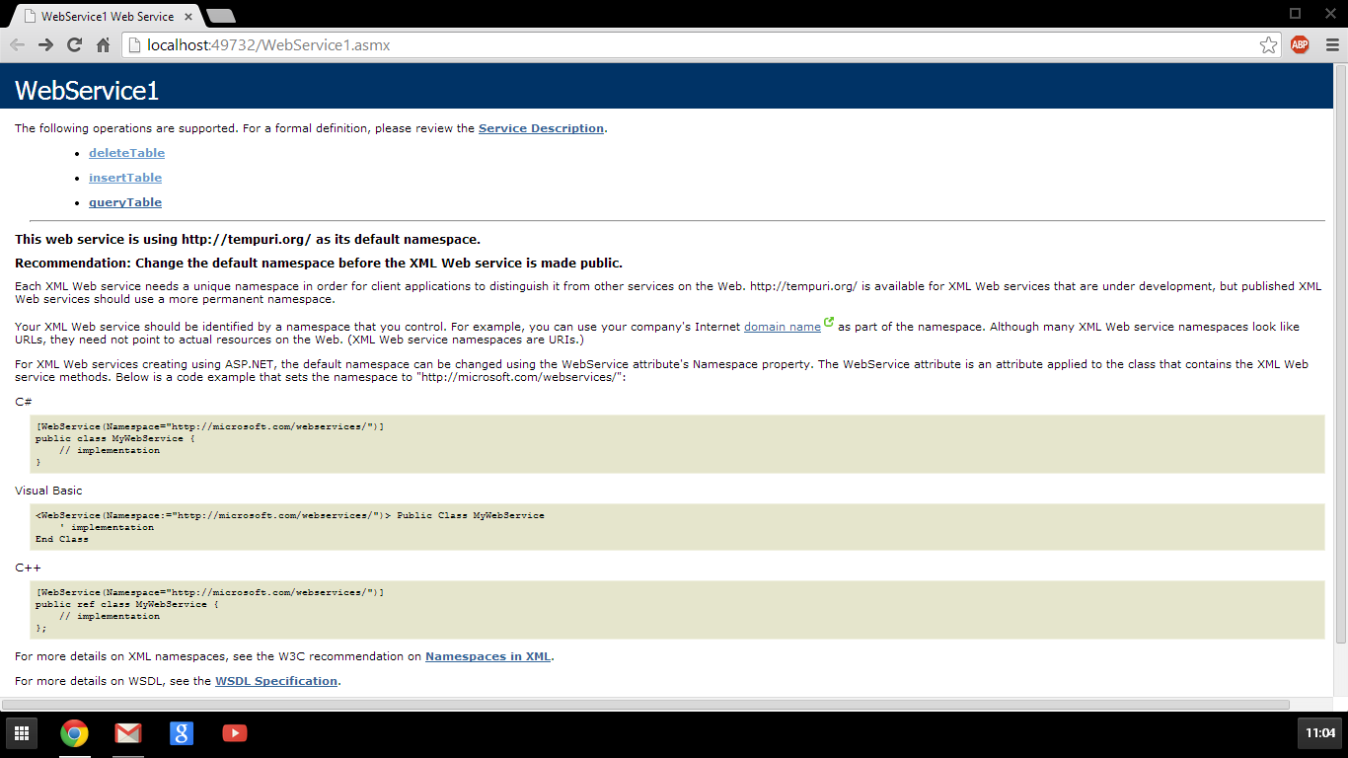

**Step 2:** this is the insertion page which will be displayed for the user when they try to insert the required data into my web service.

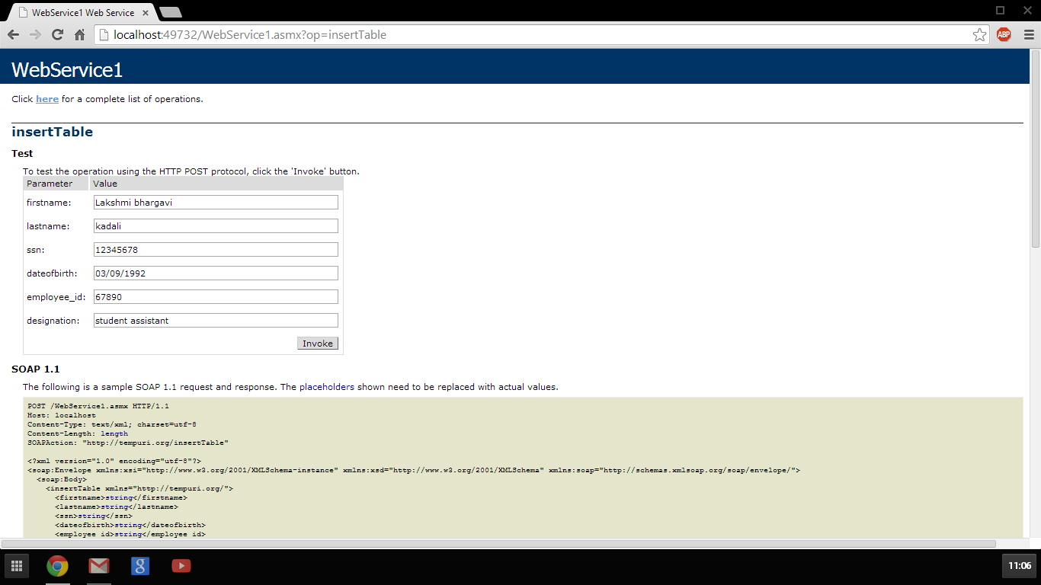

**Step 3:** this is the page that is displayed to the user when they try to delete anything from the web service.

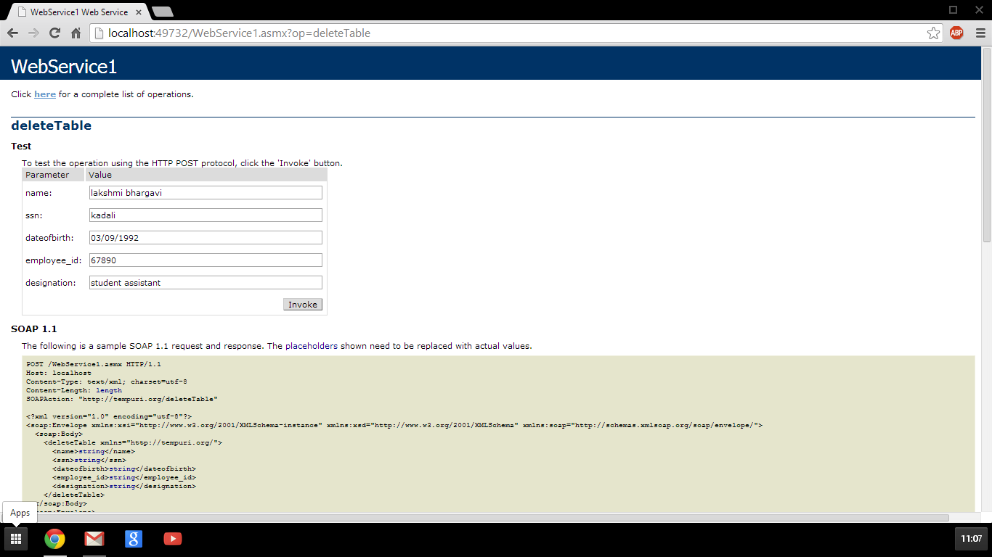

**Step 4:** this is the page that is displayed when the user tries to retrieve any information using this web service.

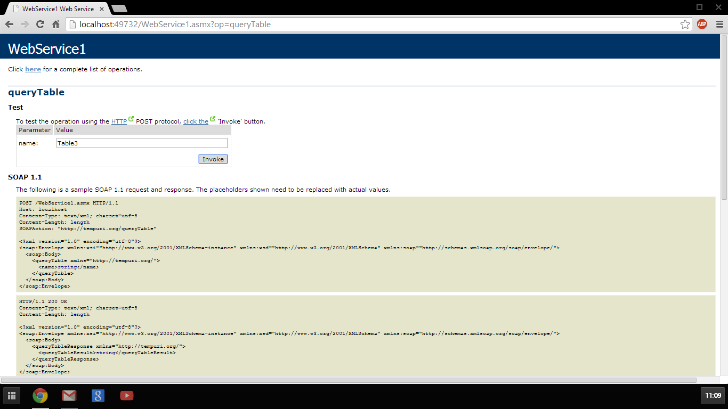

Hence, the above are all the different procedures implemented using the web application that I have created using REST and SOAP services. This also helps in implementing insertion, deletion and updating using my application.